

Indiana Department of Child Services
Child Support Bureau

INvest Project Management Office
Request for Services

Technical Proposal
Attachment F

Introduction
The Indiana Child Support Bureau (CSB) will select a qualified Project Management Office (PMO) vendor to manage the overall effort to design, develop, and implement the new statewide automated child support system to replace Indiana’s current certified child support enforcement system, Indiana Support Enforcement Tracking System (ISETS). The new system, the Indiana Verification and Enforcement of Support (INvest), is fully described in Request for Service (RFS) 19-081 (referred to as the “DDI RFS” throughout this document) and the replacement effort will be known in this document as the “INvest Project”. The PMO vendor must be familiar with RFS 19-081 and the Design, Development, and Implementation (DDI) vendor requirements described therein. Key documents from DDI RFS 19-081 and the Quality Assurance (QA) RFS 16-47 can be found in the Bidder’s Library (Attachment K).
The awarded contractor for the scope of work described in this document will be known as the INvest PMO vendor, or simply the PMO vendor. CSB will also select a qualified vendor for Independent Verification and Validation (IV&V) and has already procured a vendor for QA tasks.
CSB expects the PMO vendor to work collaboratively with the CSB INvest management team (see Section 2.1), the DDI vendor, QA vendor, IV&V vendor, and other relevant stakeholders as identified by CSB to ensure a successful INvest implementation.
High-level INvest Vision
The vision for a new federally certifiable statewide-automated child support system is, at its core, a secure, user intuitive, robust, and nimble system that is an effective tool for maximizing the performance and success of the Indiana Child Support Program. To achieve this vision, INvest must meet the following goals in Figure 1.

Figure 1 - INvest Vision
INvest must automate routine tasks; provide automated workflows to help users perform required tasks, and present users with automated work tasks to alert them to new information or the need to take action.
Implementation of INvest represents CSB’s desire to shift to the agile software development methodology, incorporation of cloud-based technology solutions over green screen applications, and an improved governance structure to manage and oversee the implementation of INvest while maintaining ISETS in production until it is decommissioned.
Overview of Scope
CSB has the following key expectations of the PMO vendor for this procurement:
- To work collaboratively with CSB and the DDI, QA, and IV&V vendors, and embrace and promote a “one team” philosophy
- Adhere to diligent project management practices, present tactics and strategies to manage the triple constraints of time, cost, and quality
- Develop and maintain an overall master Project Management Plan (PMP) that combines the PMO, DDI, IV&V, and QA vendors’ PMPs
- Develop and maintain an overall master project schedule that links to or integrates the PMO, DDI, QA, and IV&V vendor schedules
- Track delivery and review all DDI, QA, and IV&V deliverables; provide review results and recommendations to CSB including accept/reject recommendations for each deliverable
- Verify and validate the information in the DDI vendor’s status reporting, including progress updates on time, cost, and quality measures, and proactively identify course corrections, when needed
- Take responsibility and ownership of the requirements management process and implementation of the entire INvest product backlog
- Work closely with the QA vendor to establish INvest quality, performance standards, and measures for the DDI vendor, and ensure the DDI vendor meets Indiana and the federal Office of Child Support Enforcement (OCSE) certification requirements throughout INvest
- Develop the INvest Annual Advanced Planning Document Updates (AAPDU)

As described in the DDI RFS Attachment F, CSB has completed several projects and undergone training in recent years to prepare for INvest. CSB is currently undergoing agile training for all staff.
CSB and its stakeholders will be undergoing a digital transformation throughout the INvest Project. CSB will create and execute an organizational change management (OCM) Plan. The PMO vendor will verify CSB, with the assistance of the DDI vendor, has completed the plan which includes organizational models for county and CSB offices.

Indiana IV-D Program
In 1975, Congress amended the Federal Social Security Act creating the Title IV-D Child Support Enforcement Program. Title IV-D requires every state to provide child support services. OCSE is responsible for regulating the Title IV-D Child Support Program and providing guidance to states and tribes regarding implementation of services. Child support programs are administered in every state by a designated state agency.
In Indiana, the Department of Child Services, CSB is the designated single state agency with responsibility for administering the IV-D Program. However, Indiana is state administered and county operated. The majority of the direct services for the Indiana IV-D Program are provided locally in Indiana’s 92 counties through County Partners including county Prosecuting Attorneys, and county Clerks of Circuit Court. Additional information on the IV-D Program can be found in the DDI RFS.
CSB and the County Partners work collaboratively to provide the services of the IV-D Program including:
- Paternity establishment
- Locate services
- Establishment and enforcement of child and medical support obligations
- Collection, distribution, and disbursement of support payments
The IV-D Program services are a shared task involving numerous stakeholders. Figure 2 depicts the various stakeholder relationships.
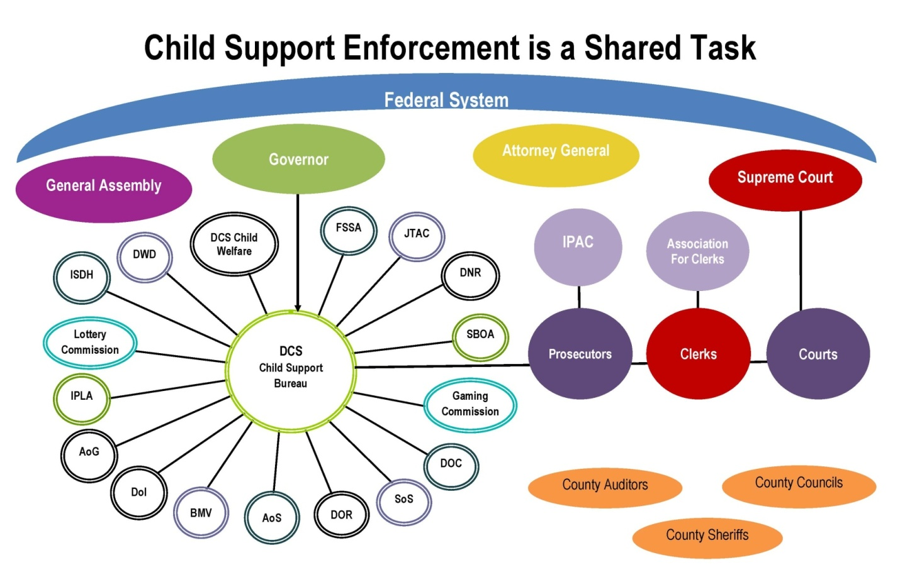
Figure 2 – Stakeholder Relationships
The following are key points about Indiana’s IV-D Program:
    - It is State-administered and county operated.
    - Services in the 92 counties are provided by elected county prosecutors and clerks
    - Indiana is “highly judicial” with:
      - Paternity established judicially and by paternity affidavit.
      - Support orders are established judicially.
      - Enforcement occurs via both administrative and judicial remedies (civil and criminal).
    - ISETS contains both IV-D and Non IV-D (NIVD) cases.
    - Indiana’s open IV-D caseload for FFY 2018 was 258,110.
    - The open NIVD caseload as of FFY 2018 was 283,155.
    - The total caseload for FFY 2018 was 541,265.

CSB INvest Management Team
The PMO vendor must read and understand the organizational structure and roles for the CSB INvest management team described in Chapter 5 of Attachment F in the DDI RFS. Figure 3 represents the CSB organizational structure to support the INvest Project. The INvest PMO Manager is a PMO vendor staff member further described in Section 3.1.1.

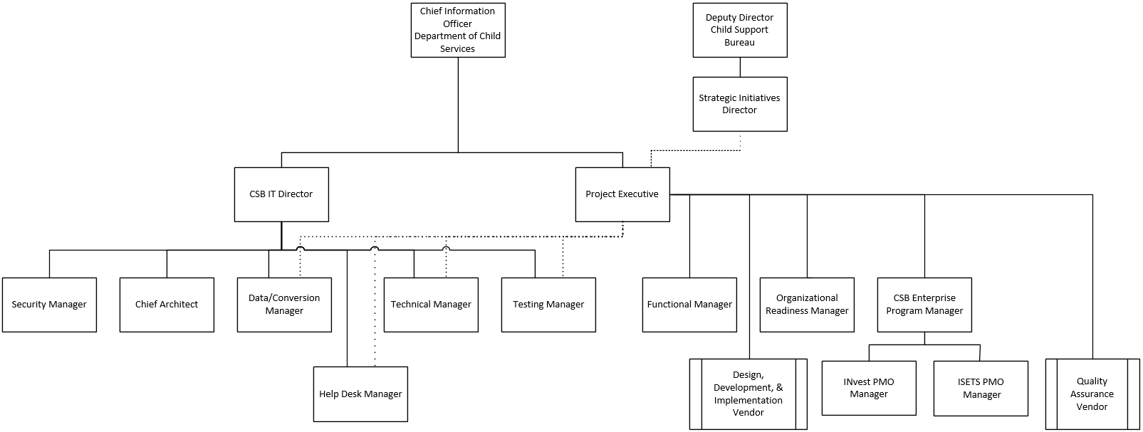

Figure 3 - CSB INvest Management Team

State Resources
As described in the DDI RFS, the State has committed several resources to the INvest Project. Select key resources and role descriptions are provided below.

Project Sponsor/Executive
The DCS Chief Information Officer (CIO) is the Project Sponsor/Executive for INvest. All project activities will be conducted under the authority of DCS/CSB. The roles provide project funding authority and oversight, makes major decisions, and assists with issue resolution. Responsibilities include:
- Providing daily oversight of the DDI vendor activities.
- Managing the DDI, PMO, and QA vendor contracts.
- Ensuring collaboration occurs among State and vendor management teams.
- Delivering daily project accountability and decision management.
- Addressing escalated business, policy, and project issues.
- Liaising to vendor’s executive team.
- Managing vendor and State staff project team relations.
- Providing a complete and thorough review and sign off on project deliverable documents and milestones.
- Providing governance oversight.
- Engaging with DDI vendor to ensure knowledge transfer for all applicable areas and staff.
- Collaborating with the CSB-IT Director

CSB IT Director
The CSB IT Director reports to the DCS CIO and ensures the overall system solution meets the INvest technical requirements and budget. The CSB IT Director will:
• Ensure the architecture, infrastructure, and security are sound.
• Hold responsibility for the overall INvest Project budget.
• Report and communicate to DCS executives, IOT, and other applicable state agencies regarding project health and budget status.
• Manage the Advanced Planning Document (APD) reporting process and OCSE communications.
• Manage staff maintaining legacy systems.

CSB Functional Manager
The Functional Manager reports to the Project Executive and is responsible for ensuring the INvest functional requirements are fully implemented in INvest. The Functional Manager will:
• Manage CSB’s Functional Analyst (FA) team.
• Serve as business authority for day-to-day activities related to requirements confirmation, design reviews, and UAT.
• Ensure that the DDI vendor solution meets all functional requirements.
• Provide oversight for any research related to functional requirements.
• Ensure that the user/business perspective drives the majority of system decisions.
• Ensure change control requests are aligned with functional requirements and approved as appropriate.
• Provide a complete and thorough review and approval of the project deliverable documents and milestones related to requirements confirmation, design, and UAT.
• Lead system certification process and walkthrough for OCSE.
• Liaise with the OR Team to coordinate and strategize communications to engage all state and county stakeholders.
• Engage with DDI vendor to ensure knowledge transfer for all applicable areas and staff.

CSB Enterprise Program Manager
The CSB Enterprise Program Manager will provide oversight to the INvest and ISETS PMO’s. This individual’s responsibilities include:
- Understanding how the different projects interlink and overlap
- Monitoring staff utilization and allocation
- Coordinating the projects and their interdependencies

CSB State Project Staff
The awarded PMO vendor will be expected to work closely with the CSB project staff assigned to this project. CSB project staff will be available to attend meetings, interviews, and assist the PMO vendor staff in reviewing project responsibilities with the awarded PMO vendor. CSB project staff will be assigned to the project on an as-needed basis, as determined by Project Executive and CSB IT Director to assure adequate State representation of the various business, functional, and technical domains.

INvest Project Vendors

Independent Verification and Validation
A separate procurement will be issued for an IV&V vendor. The IV&V vendor will report directly to OCSE. The IV&V vendor will semi-annually (every six months) assess the project artifacts, project schedule, process and product quality, and management of the overall project. The IV&V vendor will provide reports and findings to OCSE and the State as specified in 45 CFR 307.15(b)(10)(ii).
The IV&V vendor must be independent and cannot be associated with any vendor awarded a contract as a part of the DDI, PMO, or QA procurements. Also, per a letter dated February 5, 2015 from OCSE, the IV&V vendor may not have previously provided services related to the INvest Project, nor currently provide other contract services for the Indiana child support program, its umbrella agency, or any system that will interface with INvest.

Quality Assurance
The QA vendor (CSG Government Solutions) provides independent, daily oversight of the project’s project management monitoring and control structures and project artifacts to ensure adherence to the project’s defined quality standards and adherence to national child support modernization best practices and established technology, PMO, and security best practices. The QA vendor also reviews deliverables and work products to ensure that the deliverables in fact fulfill the defined acceptance criteria. Finally, the QA vendor ensures that the new system’s architecture, database structure, programming code, and ease of use features adhere to the agreed upon design standards.

Design, Development, and Implementation
The DDI vendor is responsible for developing and implementing all functional and technical requirements for INvest. This also includes providing deliverables such as solution architecture, data conversion, training, and organizational change management planning. The DDI vendor will be held accountable for delivering a system that will be certified by OCSE.

INvest Project Management
Ensuring that all aspects of the INvest Project run efficiently and effectively from planning through close out will require strong project management with strict adherence to the INvest Governance Manual. CSB has developed a project management approach and requires the PMO and DDI vendors to adapt to this approach and also bring project management best practices from previously delivered large system projects. Project success will be achieved by applying the combined knowledge, processes, skills, tools, and techniques from these sources to the INvest Project.
Throughout this multi-year project, CSB expects the PMO vendor to monitor and ensure that the DDI vendor leads and manages the design, development, and implementation activities to ensure quality, cost effectiveness, and timeliness while meeting all requirements and vision for INvest. The PMO vendor will work with the DDI vendor to develop and maintain a master PMP that links to and imports details from the PMO, DDI, QA, and IV&V vendor PMPs. The primary goal and objective of the master PMP and the associated vendor PMPs is to ensure all milestones have been appropriately planned and monitoring is in place to ensure completion. The achievement of federal certification is the ultimate goal for the INvest Project.
The INvest Project will be collaborative. A key to a successfully managed project will be the engagement and communication with CSB staff, county partners, applicable stakeholders, and interface partners throughout the project lifecycle. CSB expects the PMO vendor to strive to create and maintain a culture of “one team” throughout the INvest Project.
The following sections provide the staffing, background, details, and requirements for the INvest PMO.

PMO Vendor Staffing
The PMO vendor will need to provide a team with project management, business requirements, and agile expertise. The team should have skills in communication, reporting, quality, scheduling, risk and cost management, requirements management, and monitoring as well as understanding of OCSE expectations for AAPDUs. The PMO vendor must provide experienced staff for the following Key Positions: INvest PMO Manager, Requirements Coordinator, Master Scheduler, and Document Librarian/Technical Writer.

INvest PMO Manager
The INvest PMO Manager will assume primary day-to-day responsibility for project management oversight of the INvest PMO. The INvest PMO Manager reports to the Project Executive and is responsible for overall project management, quality assurance, and adherence to project scope, requirements, risk management, quality, and schedule parameters. Other responsibilities of the INvest PMO Manager include:
- Manage the INvest PMO staff.
- Make daily project decisions as needed and escalate issues to the CSB Enterprise Program Manager, Project Executive, CSB IT Director, and Functional Manager.
- Responsible for the development and maintenance of the master project risk and issue log.
- Ensure all internal project communications and reporting is occurring.
- Provide a complete and thorough review of project deliverables and ensure review and approval milestones are met.
- Develop and maintain the master project management plan (PMP) and master schedule for the INvest Project.
- Ensure, in conjunction with the DDI, QA, and IV&V vendors, the INvest Governance Manual is being followed for project quality.
- Convene the Change Control Review Board based on INvest Governance Manual processes.
- Work closely with the CSB IT Director to report, track, and manage costs throughout the entire project lifecycle.

Requirements Coordinator
The position duties will include at a minimum:
- Knowledge of the IV-D Program, Requirements Management, and agile methodology.
- Facilitate and manage the requirements process.
- Collaborate with Functional Analyst Team and Manager to ensure requirements management practices are in place and followed.
- Communicate with the INvest PMO Project Manager(s) and CSB Product Owners/Functional Analysts to ensure product backlog is planned and completed.
- Oversee that the federal certification process and traceability are successfully occurring throughout the project.

Master Scheduler
The position duties will include at a minimum:
- Create a combined project schedule from different sources and update it daily/weekly.
- Knowledge and understanding of agile methodology.
- Ability to develop a work breakdown structure (WBS) and decompose work into manageable tasks.
- Identify task and resource dependencies.
- Communicate and report schedule issues, risks, or slippage.
- Forecast “what if” scenarios or modeling of the schedule.
- Assign, allocate, and level resources at the task level.

Document Librarian/Technical Writer
The position duties will include at a minimum:
- Create a strategy and then maintain all project documentation outside of the application lifecycle management (ALM) tool.
- Work with CSB to produce the Annual Advanced Planning Document Update (AAPDU) for INvest.
- Produce and update documents that meet the intended audience requirements.
- Ensure style guide, quality, grammar, and readability are addressed in all PMO vendor output.
The PMO vendor should identify any additional Project Managers (PM) and/or Project Coordinators to meet the requirements in this RFS. CSB requires Project Management Institute certifications for senior PM roles. CSB also requires all team members to be trained and/or certified in agile. Requirements management staff having business analyst certifications are a plus.
The PMO vendor is required to co-locate key vendor staff with CSB, Monday through Friday, typically 8am to 5pm. CSB approved off-site resources will provide a working schedule to CSB Management. All off-site staff will be made available to CSB when needed. Off-site staff are required to travel to the project site if requested by CSB. Off-site employees or premises will be made available for CSB security audits, at the discretion of CSB. All work must be performed within the United States.
The PMO vendor will be required to complete all necessary background checks according to IRS Publication 1075 and in accordance with Indiana State policy and the PMO vendor contract before joining the INvest Project.
All vendor staff are required to be non-delinquent on any child support obligations.
In alignment with all requirements described in Section 3.0, the PMO vendor must provide each PMO vendor staff member with a computer and software necessary for the project, unless otherwise provided by the State. All non-State-owned equipment must be authorized and approved, in writing by a CSB authorized representative. Non-State-owned equipment must maintain the highest level of protection, including full disk encryption, CSB approved antivirus software, up-to-date system, and other software patches. Equipment will be subjected to security audits at the CSB Security Manager’s discretion.
The PMO vendor will provide technical support and maintenance of non-State owned equipment / laptops.
The PMO vendor will provide options for a networking solution to access State computing resources / assets at the INvest Project site, which may or may not be owned and operated by the PMO vendor (e.g., setting up a WAN connection with site-to-site VPN tunneling).
The PMO vendor will utilize the State-provided network.
Response Requirements
a. Agree to the requirements of this Section.
b. Explain the resource staffing philosophy and approach for a project of this size. The Respondent may propose any best practices and recommendations related to management structure, approach, and roles.
c. Provide an overall INvest Project organizational chart that depicts all proposed vendor staff positions/teams and clearly identifies Key Person roles. Ensure a sufficient number of staff to accomplish all required tasks and demonstrate how the PMO vendor will be responsible for appropriately managing staff and staff resource levels throughout the life of the project. For the positions/teams with named staff, indicate the name. For the positions/teams with specific staff names to be determined, indicate the number of staff anticipated. Denote Key Persons positions, sub-contractor resources, and whether the positions/teams will be working onsite at the CSB facility or off-site. (Note: At a minimum, specific named individuals must be identified for Key Positions as part of your response)
d. Provide a completed Vendor Roles and Resources Template, Attachment H, that has two worksheets – one for role information and one for specific Resource information.
- For any filled positions and for all Key Positions, list the proposed person’s name, the role to be filled by that person, and a clear description of how that person is fully qualified for that role. Separately, include a resume detailing relevant skills, experience, education, certifications, etc. that ties back to the above description. Provide a letter of intent from the sub-contractor if the individual is not an employee of the prime vendor.
- If the Respondent is unable to name a specific resource for non-key positions, submit a description of the skills the Respondent will be seeking to fill the positions. Once a resource is named, a resume must be provided 30 days prior to the individual onboarding.
- For both of the above, if the proposed person/position is to fill multiple roles, clearly delineate the roles and the percentage of time allocated to each role.
e. Please explain if the Respondent’s team has worked together before (and in what capacity) and if not, how the Respondent will develop a collaborative and solid team to manage the INvest Project.
f. Please detail all the subcontractors the Respondent proposes to use on this contract. Also explain:
- If the Respondent has worked with each subcontractor before (and in what capacity).
- The role each subcontractor will play and when during the contract their services will be utilized.
- The subcontractors’ experience and qualifications for their proposed role.
- How the subcontractors will be incorporated into the “one team” concept
g. Explain the reasons for any off-site work to be done by the Respondent’s resources.
h. Provide the contact information and hours of operation of the resources who will provide technical support and maintenance of non-State owned equipment / laptops.

Project Kick-Off Meeting
- A project kick-off meeting will be held with representatives from the State and the DDI, IV&V, and QA vendors and the PMO vendor after contract approval and prior to work performed. The PMO vendor will schedule and facilitate the project kick-off meeting. Items to be covered in the kick-off meeting will include, but will not be limited to:
- Deliverable review process
- Determining format and protocol for project status meetings
- Determining format for project status reports
- PMO vendor’s approach to establishing the schedule of meetings with representatives from the State and DDI/QA/IV&V vendors to develop and maintain the master PMP and schedule
- Defining lines of communication and reporting relationships
- Reviewing the project mission
- Approach to proactively pinpointing high-risk or problem areas
- Issue escalation and resolution process

Response Requirements
a. Agree to the requirements of this Section.

CSB Project Management Approach
The foundation to CSB’s project management approach is the organizational structure, processes, and tools established that ensure projects are delivered in a consistent manner. CSB’s approach to disciplined project management is documented in the INvest Governance Manual.
The INvest Project will be a coordinated project management effort amongst all CSB, PMO, DDI, QA, and IV&V vendor staff. Communication, collaboration, facilitation, and diligent project management practices will be crucial to ensure activities are coordinated and completed, messages are effectively communicated to teams and stakeholders, and risks and issues are proactively escalated and resolved promptly. CSB envisions this coordinated effort to focus on creating a “one team” approach throughout the project. From this point forward, all CSB and vendor team members will be called the “INvest Project team”.
The INvest Project will be managed through the CSB Project Executive who has overall daily executive management authority and is supported by the CSB Enterprise Program Manager, INvest PMO, QA vendor, IV&V vendor, and CSB business and technical managers. This project management team structure defines roles and responsibilities that will aid the Project Executive and the PMO vendor to actively monitor the planning, execution, and quality of the project. The CSB INvest management team members will monitor and participate in vendor activities, and review and approve project deliverables along with team staff.
The PMO vendor will have the following responsibilities:

- The PMO vendor is responsible for planning and managing the INvest PMO. The PMO vendor shall follow the project management methodology laid out in the INvest Governance Manual and established CSB processes and make certain the project management methodologies and processes are understood and adhered to among the project teams. Project management requires a set of skills that must recognize the coordination and facilitation needed to balance the needs and requirements that exist across people, technology, budget, and expectations.
  - The DDI vendor will first review the INvest Governance Manual and provide feedback of how the INvest Governance Manual differs from the DDI vendor’s proposed SDLC and agile methodologies. The feedback will include suggested improvements recommendations to the INvest Governance Manual. DCS will determine what recommendations they would like to incorporate.
  - The PMO vendor will review the INvest Governance Manual and the accepted recommendations from the DDI vendor and provide a gap analysis of the differences from the PMO vendor’s preferred SDLC and agile methodologies approach. The PMO vendor will include suggested improvements recommendations to the INvest Governance Manual. DCS will review the PMO vendor’s recommendations and determine what flexibility can be given to accommodate the PMO vendor’s preferred processes.
  - As the owner and administrator of the INvest Governance Manual, the QA vendor will work with CSB, the DDI vendor, and the PMO vendor to update the INvest Governance Manual based on the improvement recommendations for INvest. The QA vendor has oversight to assure the updated governance processes are followed throughout INvest and will work collaboratively with the DDI and PMO vendors.
- The PMO vendor will generate and execute a Project Management Plan (PMP) that clearly explains how the PMO scope of activities will be managed. The PMP should contain (or link to), at a minimum, the following sections:
- Project Overview
- Project Structure
- Project Deliverables
- Work Breakdown Structure
- Milestones
- Baseline Schedule
- Resource Management
- Vendor Management
- Deliverables Management
- Requirements Management
- Schedule Management
- Cost Management
- Quality Management
- Stakeholder Management
- Communications Management
- Progress Monitoring and Reporting
- Risk and Issue Management
- Project Change Control
- Project Closure
- The PMO vendor will work with the DDI vendor management team and the CSB management team to help facilitate the project schedule, cost, and quality efforts to ensure a successful outcome. The PMO vendor will maintain the master PMP for the INvest Project, including a master schedule, risk and issue and communications matrices. Each vendor will be responsible for regularly submitting and updating individual PMPs and schedules.
- The PMO vendor is responsible for adhering to diligent project management practices throughout INvest to keep the project on track, and is ultimately responsible for effectively managing the competing project constraints of scope, quality, schedule, cost, and risk. The PMO vendor will proactively identify when course corrections are needed to get INvest back on track, and follow a formalized process of identifying options, pros and cons, etc., for each option considered, and make recommendations to CSB for decision.
- The PMO vendor will work closely with the Project Executive to track delivery and review all DDI, QA, and IV&V deliverables and milestones throughout the life of the project. The PMO vendor will provide review results and recommendations to CSB, to include accept/reject recommendations for each deliverable. The PMO vendor is required to follow the updated INvest Governance Manual and utilize the project tools selected for the project.
- As described in Attachment F, Section 6.8 Project Tools of the DDI RFS, CSB will select an application lifecycle management (ALM) tool recommended by the DDI vendor in an effort to standardize the scheduling, collaboration, reporting, testing, and artifact storage aspects of INvest. The PMO vendor will utilize the CSB-approved ALM tool throughout INvest. CSB is open to consideration of a project management tool, if the PMO vendor would like to recommend a project management tool that compliments the approved ALM tool.
- Additionally, the PMO vendor shall be responsible for:
  - Bringing a best practices approach to capturing and reporting earned value project progress in an agile context throughout the project
  - Effective backlog management
  - Requirements prioritization and management
  - Requirements traceability
  - Managing the daily status meetings
  - Ensuring lessons learned are documented and shared
  - Schedule management
  - Weekly, monthly, and quarterly status reporting
  - Knowledge transfer throughout the project to the ISETS PMO team

Response Requirements
a. Agree to the requirements of this Section.
b. Describe the approach that the Respondent will use to collaborate with the DDI vendor to adapt to the DDI vendor’s agile approach while incorporating its own best practices for effectively managing the competing constraints of scope, quality, schedule, cost, and risk. Demonstrate where the Respondent has operated in a similar environment for a similar sized project.
c. Provide a high-level description of the Project Management approach proposed by the Respondent. Provide a PMP from a previous project of a similar nature and size. The Respondent may recommend additional sections to ensure a comprehensive PMP.
d. Explain the approach the Respondent will use to satisfy the requirement of providing a gap analysis of how the INvest Governance Manual and the DDI vendor’s recommendations differ from the PMO vendor’s proposed SDLC and agile methodologies.
e. CSB is open to the addition of a non-proprietary project management tool if the Respondent would like to recommend one that compliments the CSB-approved ALM tool. The project management tool will be transferred to CSB at the conclusion of the INvest Project. If a project management tool is recommended, describe the features and potential drawbacks of the tool.

Cost
The State has committed significant resources to the INvest Project. CSB’s cost management process will help ensure the INvest Project is progressing and ultimately completed within the approved cost baselines. The CSB IT Director has responsibility for the budget. The INvest PMO vendor will work closely with the CSB IT Director to report, track, and manage costs throughout the entire project lifecycle. The PMO vendor will be required to ensure the DDI vendor appropriately manages fiscal stewardship in order to minimize change control and cost overruns.
Response Requirements
a. Agree to the requirements of this Section.
b. Describe approach the Respondent will employ to ensure the DDI vendor appropriately manages fiscal stewardship in order to minimize change control and cost overruns.

Quality
Quality is a critical component for this project. It is imperative that the entire INvest Project team works to ensure a high level of quality across the board from work packages to deliverables. CSB procured a QA vendor to provide daily, on-site, proactive support for project quality. In addition, the INvest Project will have the federally mandated IV&V oversight.
The PMO vendor and QA vendor will create objectives, standards, practices, and responsibilities for performing project quality management. The PMO vendor shall work with the QA vendor to also establish the tools (e.g., checklists) and templates (e.g., delivery expectation document) to conduct quality assessments. The PMO vendor will be responsible for proactively communicating the quality standards and results to the INvest Project team. The QA vendor is responsible for tracking the quality standards and reporting them to the PMO vendor and the Project Executive. The DDI vendor will be required to adhere to all project quality objectives, standards, and practices.
CSB and all vendors will identify and monitor work performance measures that will gauge the INvest Project’s health. If performance measures identify an improvement is needed, the PMO vendor will assist in the effort.
The PMO vendor shall develop and utilize an internal quality assurance process throughout the INvest Project. All PMO vendor deliverables and work products shall be complete, error-free, and meet all quality criteria.
The PMO vendor shall create a quality management plan detailing its internal quality process as part of their overall PMP. The quality management plan must also describe how the PMO vendor staff shall ensure the DDI vendor meets the quality requirements for INvest.
Response Requirements
a. Agree to the requirements of this Section.
b. Describe how the Respondent will ensure all of their work products are complete, error-free, and meet all quality criteria.
c. Include a sample quality management plan from a similar project.

Planning and Schedule
The INvest Project requires a concerted planning effort to successfully reach the project goals.
- The project schedule is a key component to project management. The PMO vendor will be in charge of the master schedule in order to maintain that schedule’s accuracy. The schedule will be reviewed consistently by the PMO vendor’s Master Scheduler to ensure the project is completing the activities, deliverables, and milestones according to plan. The master schedule will be a combination of all vendor and CSB schedules.
- CSB expects the DDI vendor to collaborate with the PMO vendor and applicable CSB staff in the creation of the plan and the schedule.
  - The DDI vendor will create and execute several major planning deliverables over the course of the project. Approval of the major planning deliverables will be necessary prior to initiating any SDLC activities. All required major DDI deliverables are listed in the Deliverables Matrix from the DDI RFS, Attachment G as well as details for each major plan, minimum expectations for content in Attachment F. These documents can be found in the Bidder’s Library (Attachment K).
  - CSB expects the DDI vendor to use the experience gained on other child support and system-related projects to propose a schedule that is reasonable and attainable based on the requirements. Once planning commences, the schedule will be refined and baselined and the DDI vendor will be held accountable to the agreed-upon schedule.
- The PMO vendor shall comply with all applicable federal and state laws, policies, procedures, and standards created by CSB in meeting the goals and objectives of the INvest Project.
- The PMO vendor shall follow any standards and methodologies included in approved planning deliverables. If a QA or IV&V vendor quality finding or a continual improvement effort changes standards, methodologies, or processes, the plans will need to be modified and reapproved at CSB’s request. The PMO vendor will also promote continual improvement in processes (e.g., sprint reviews), especially the processes based on QA or IV&V finding recommendations.
- The PMO vendor shall plan for QA review and periodic IV&V review of DDI deliverables in the master schedule. The DDI vendor deliverables will be subject to quality review and approval process by the QA vendor and CSB to determine adherence to INvest quality requirements and standards. Deliverables will also be reviewed by the IV&V vendor during periodic review activities.
- The PMO vendor shall ensure that the DDI vendor creates and manages the DDI schedule based on the overall system solution proposed for all requirements in this RFS. The PMO vendor will ensure that the DDI vendor keeps the DDI schedule accurate, updated daily, and available to CSB for informational purposes and to the PMO vendor for importing into the master schedule.
- The PMO vendor will provide a monthly Executive Report to CSB’s Project Sponsor/ Executive and CSB IT Director. Provide a summary of schedule, cost, and quality impacts or milestones observed in the month. This will also include agreed upon key project metrics such as:
- Project performance standards
- System performance standards
- Work performance standards
- Cost variances
- Schedule variances
- Schedule performance index
- Planned value
- Cost performance index
- Earned value
- Resource allocation
- Agile velocity and burn down
- When any required hardware, software, or service must be procured and implemented for the INvest Project by CSB, the PMO vendor shall regularly check with the DDI vendor about any such procurement needs for hardware, software and services. The INvest PMO vendor will communicate this need and work with the CSB IT Director.
- The PMO vendor shall work with the DDI vendor to address and monitor IV&V and QA findings and ensure the completion of identified observations/findings/action items/issues in a timely manner as agreed upon by CSB and the PMO vendor.
- The PMO vendor shall create and monitor the master project schedule to help ensure the development and implementation of INvest in three years.
- The PMO vendor shall monitor and proactively report the DDI vendor’s quality, cost effectiveness (i.e., did the DDI vendor meet the cost baseline), and timely completion of all DDI deliverables and milestones.

Response Requirements
a. Agree to the requirements of this Section.
b. Describe past similar experiences in promoting continual improvement and lessons learned from past projects of a similar scope.
c. Explain how the Respondent will plan for quality reviews of DDI vendor deliverables by the QA vendor and CSB, and periodic reviews by the IV&V vendor.
d. Describe how the Respondent will manage and own the master schedule and keep it up-to-date based on regular DDI vendor updates.
e. Provide a sample executive report from another project of similar size and scope.
f. Explain any tools and skills the Respondent will bring to create and monitor the master project schedule and help ensure the development and implementation of INvest in three years.
g. Describe the approach that the Respondent shall use to monitor DDI vendor’s quality, cost, effectiveness, and timely completion of all DDI vendor deliverables and milestones.

Federal Child Support System Certification
Any child support enforcement system being built must be federally certificated in accordance with the latest version of the document “Automated Systems for Child Support Enforcement: A Guide for States” from OCSE. These requirements will need to be met by the system with absolute adherence. The INvest Project will require the PMO vendor and State resources to closely monitor issues, progress, and reporting related to federal certification. This area will be given high priority and continual oversight by both the PMO vendor and CSB executives.
The PMO vendor will have the following responsibilities:
- The PMO vendor shall be responsible for managing the project to ensure that the DDI vendor delivers a complete and functional INvest system that is certified by OCSE.
- The PMO vendor shall ensure that the DDI vendor successfully executes the federal test deck, including creating all documentation to explain and document results. The PMO vendor shall be responsible for reviewing the DDI vendor’s written responses for the federal certification process and proving traceability to INvest requirements. The PMO vendor shall assist the DDI vendor and CSB with the development of any responses, presentations, or on-site visits with OCSE. When requested, the PMO vendor shall lead the data gathering and content development for certification-related documents.
- The PMO vendor shall ensure the DDI vendor provides an ongoing analysis of any federal certification and/or federal test deck gaps believed to exist. The PMO vendor will verify the DDI vendor is producing a quarterly certification report detailing certification efforts, issues, and resources. Issues deemed urgent by CSB may be required to be reported in a more frequent manner.
- The PMO vendor shall ensure the DDI vendor adheres to any future federal certification requirements or state law changes published in any new or revised certification guide, other federal communications, or state law. The PMO vendor will assist CSB and the DDI vendor with the change control process as necessary.

Response Requirements
a. Agree to the requirements of this Section.
b. Describe the Respondent’s experience delivering a certified OCSE system or relevant certification experience.
c. Describe the Respondent’s staff and corporate experience with the federal certification process.
d. Describe the Respondent’s certification risk analysis and reporting approach. It should be based on best practices and experience.
e. Provide a plan on how to monitor updated publications and communications related to future federal certification requirements or state law changes.

Requirements Management
Requirements management will be key to ensuring the INvest requirements are being met throughout the project. The ultimate goal of requirements management is to deliver a federally certified system that also meets INvest requirements (i.e., features).
At a high level, there are six (6) INvest “core” functional modules:
- Case initiation
- Establishment
- Enforcement
- Locate
- Case Management
- Financials

The functional requirements (see DDI RFS Attachment F, Chapter 7) include business process models (BPMs), business services, and use cases (UCs). The “non-core” functional requirements examples include the Enterprise Content Management (ECM), Business Intelligence/Reporting, and Global Requirements (see DDI RFS Attachment F, Chapter 8). Technical Solution Requirements (see DDI RFS Attachment F, chapter 9) examples include Architecture, Infrastructure, Mobile, and API-Driven Multigrained Service Platforms.
Since gathering the functional requirements, CSB performed a thorough analysis of these requirements. During the analysis, some requirements were further refined and some outdated and/or missing requirements were discovered. The prioritized list below represents the items that were identified during CSB’s requirements review:
- Income Withholding – Requirements written prior to State legislative and FEM changes.
- Medical Support – Requirements written prior to the Affordable Care Act (ACA).
- Uniform Interstate Family Support Act (UIFSA) – Requirements written for UIFSA 2007, not 2008.
- Flexibility, Efficiency, and Modernization in Child Support Enforcement Programs Final Rule-Requirements – Requirements written prior to this rule being published. Requirements will be needed for FIDM changes and incarcerated obligors.
- Professional License Suspension – No specific business requirements.

Requirements Confirmation
To ensure that the DDI vendor fully understands the intent and scope of the functional requirements, the CSB Functional Analysts (FAs) will go over the features of each module with the DDI vendor’s designers at the start of the contract. These sessions will be called requirements confirmation sessions and will be a critical step in the project.
The goal of the requirements confirmation sessions is to transfer the detailed knowledge and understanding of the functional requirements from the INvest FAs to the appropriate DDI vendor staff to build a common understanding of the requirements. This will also give the DDI vendor an opportunity to validate the sequencing of their proposed schedule.
The PMO vendor shall assign a Project Manager to attend the requirements confirmation sessions that the CSB FAs will lead. The DDI vendor staff will attend these sessions and to ensure continuity, identified county stakeholders will also attend these sessions. The PMO vendor will assist the CSB FAs in working with the DDI vendor during requirements confirmation to identify specific rules that need to be added, expanded upon, or rewritten to address any functional requirements missing from these areas.
The requirements confirmation sessions will last no more than two weeks depending on the length of time needed for discussion, but the CSB FAs will expedite the sessions when appropriate. The PMO vendor should reflect two weeks in the schedule for the sessions.
The agenda for requirements confirmation sessions is as follows:
- Indiana Uniqueness
- BPM Features/UC Description/Walk-Through
- Questions

Traceability
Throughout the INvest Project, each INvest requirement must be able to be traced from its origin through statewide implementation of the system via a DDI vendor-recommended application lifecycle management (ALM) tool. Changes to requirements and/or development artifacts will be tracked and maintained for historical record and certification traceability. The DDI vendor will provide a vision and methodology for documenting and maintaining traceability throughout the agile software development lifecycle, and back to source requirements. The DDI vendor is responsible for planning, tracking, and reporting requirements management activities for the INvest Project. The PMO vendor supports these activities and ensures the DDI vendor completes these tasks. The DDI vendor will be responsible for updating any CSB approved changes to the requirements after completion of the requirements confirmation session. The DDI vendor will assume full control of the requirements, making approved changes and completing all traceability activities for the remainder of the INvest Project.
The PMO vendor is ultimately responsible for facilitating and managing the overall requirements management process and ensuring requirements traceability. The PMO vendor will ensure INvest requirements and ISETS enhancements that are required for INvest Day 0 (and those requirements/features not included for delivery on Day 0) are properly identified, defined, prioritized, tracked, reported, and implemented as part of the requirements management process. The entirety of INvest requirements/features is the INvest product backlog. The PMO vendor shall be required to be thoroughly familiar with INvest requirements in order to be able to determine accurate and complete deliverables from the DDI vendor.
The PMO vendor shall work with the DDI vendor and CSB to ensure that the requirements confirmation sessions are scheduled in a timely manner and the appropriate participants attend.

Response Requirements
a. Agree to the requirements of this Section.
b. Confirm that the Respondent has read the DDI documents included with this RFS (Attachments F, G and L), found in the Bidder’s Library (Attachment K). Also describe how the PMO vendor will become familiar with the business and technical requirements.
c. Describe the approach and team members that the Respondent will use to facilitate, manage, and report on the requirements management and traceability process activities that covers the entire INvest product backlog.

Project Governance
The INvest Core Committee and the INvest PMO are two internal key roles in the existing governance structure. The INvest PMO will drive the communication between the different groups, and the Core Committee is responsible for major decisions. The CSB Enterprise Program Manager (not represented in Figure 4) is at the program level, and is above the INvest PMO and ISETS PMO to effectively manage and coordinate changes and requirements across both projects. The figure below provides an overview of the governance structure.
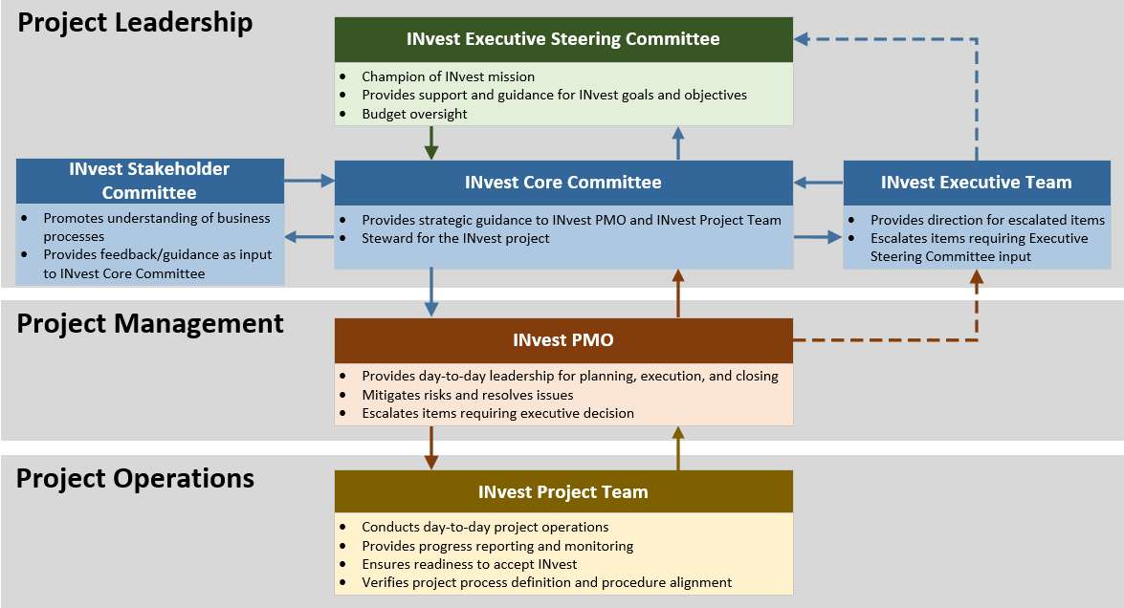
Figure 4 - Governance Organization Structure
Another vital component of the existing governance is ensuring excellent communication with the leadership of primary user stakeholders. CSB created the INvest Stakeholder Committee to facilitate ongoing dialogue with key, identified stakeholders. The current INvest Stakeholder Committee is comprised of county Prosecutors, county Clerks, IPAC staff, DCS executives, CSB management, and INvest Project staff.
The INvest Governance Manual outlines the governance structure that is composed of interrelated groups that work together to provide management and oversight of projects.
The QA vendor will review, update, and publish the INvest Governance Manual throughout the duration of the INvest Project. Updates to the INvest Governance Manual may be initiated by findings or suggestions from the DDI, QA, PMO, IV&V vendors, and requests from CSB.
CSB will collaborate with the QA vendor to update the INvest Governance Manual. Once updated, all INvest Project staff must follow the INvest Governance Manual.

INvest Agile Approach
CSB’s INvest Governance Manual updates will include a shift to a specific agile methodology, which will be determined based on the selected DDI vendor’s proposed approach. An agile methodology will break the development of INvest into smaller work efforts to realize the following goals:
- Development and deployment of a functioning component(s) at the end of every iteration that build upon each other.
- Enabling frequent demonstrations of completed components.
- Building stakeholder support for INvest throughout the life of the project, including through regular UAT efforts.
- Detecting dependencies, risks, and/or issues as early as possible to make course corrections.
- Early detection of missing, incomplete, or inaccurate requirements.
- Early detection of flaws and vulnerabilities.
- Moving at a faster pace to completion.
- Creating an environment that lends itself to responsive design to provide a seamless user experience regardless of device.
- Facilitating ongoing project team learning and continuous process improvement.
- Independent module level testing. Cross module testing. Scheduled and on-demand demos. Flexible number of iterations to accommodate all the prioritized requirements within a module.

The agile approach for INvest is to be based on known requirements realized and implemented using short cycles of analysis, design, development, and testing, enabling the system to evolve. An iteration for INvest is to be a distinct sequence of tasks focused on a desired goal within a time box, or simply multiple mini-projects that are part of a project phase.
CSB expects the DDI vendor to create and lead an architecture-driven, agile process that begins by prioritizing high-risk/high-payoff use cases within each module that have well-defined objectives and produce functionality ready for production release. Each successive iteration builds on the work of previous iterations to evolve and refine the system. The iterations can be released based on the DDI vendor’s project schedule.
Figure 5 provides an example of an agile approach for design, development, and testing of INvest functional modules. In the diagram, a sprint is the equivalent to an iteration. This figure was included in the DDI RFS as an example for the DDI vendor to use to propose an iterative approach methodology that allows:
- Independent module level testing.
- Cross module testing.
- Scheduled and on-demand demos.
- Flexible number of iterations to accommodate all the prioritized requirements within a module.
CSB is expecting agile development to occur on multiple modules simultaneously. The DDI vendor will determine which module iteration to start first and the number of iteration cycles needed within each module.
Even though the functional modules are developed using an agile methodology at different time intervals, functional implementations will begin after all user acceptance testing and QA testing has been completed and approved by CSB.

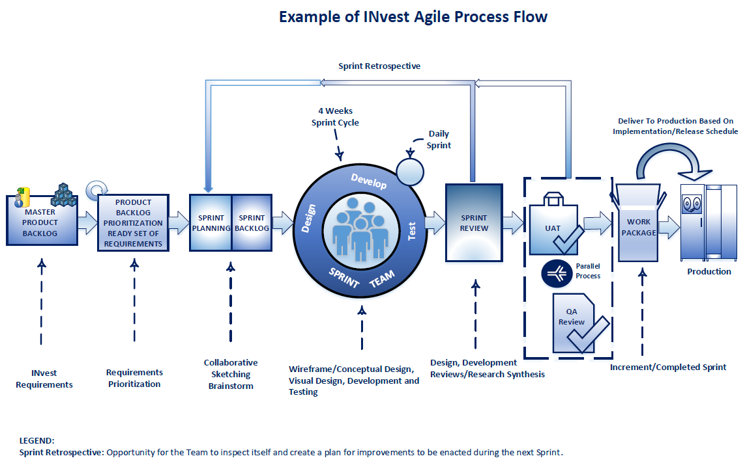

Figure 5: Example of INvest Agile Process Flows

The PMO vendor has the following responsibilities:
- The PMO vendor shall adhere to the methodologies described in the INvest Governance Manual, and will ensure that the DDI vendor and all other project staff follows the updated INvest Governance Manual throughout the life of the INvest Project.
- The PMO vendor shall ensure that the DDI vendor plans and adheres to their DDI project responsibilities. The PMO vendor shall ensure that the DDI vendor generates and executes a project management plan that clearly explains how the DDI scope of activities will be executed and managed.
- The PMO vendor will provide a weekly project status report which verifies and validates the information in the DDI vendor’s status reporting to the CSB Project Executive. This will include but not limited to:
  - progress updates on time, cost, and quality measures
  - progress updates on tasks for actual work performed and estimate to complete
  - sprint review analysis detailing impacts to backlog
  - critical federal certification challenges, risks, and issues
  - dashboard for executives plus provide adequate details throughout the report for the INvest Project team to understand any actions needed.
This is in addition to the monthly executive report in DDI RFS Attachment F, requirement 6-5.5.
- The PMO vendor shall ensure that the DDI vendor utilizes the change control process as stated in the Governance Manual. The PMO vendor shall also make an effort to help the DDI vendor and CSB to minimize change control over the life of the project.
- The PMO vendor shall document any lessons learned throughout the INvest Project and communicate them to the CSB Project Executive. The PMO vendor shall hold lessons learned discussions at the request of CSB. The PMO vendor shall ensure that the DDI vendor keep a lessons learned document, which will be incorporated in all project lessons learned meeting and reports.
Response Requirements
a. Agree to the requirements of this Section.
b. Describe the approach and staff the Respondent will use to adhere to the INvest Governance Manual, and ensure the DDI vendor and all other project staff follows the updated INvest Governance Manual.
c. Describe how the Respondent will ensure the DDI vendor plans for and adheres to their DDI project responsibilities, including development of a PMP that clearly explains how DDI scope will be executed and managed.
d. Describe how the Respondent will verify and validate the DDI vendor weekly status report information before it develops and publishes the Respondent weekly project status report. Provide a sample report from another project.
e. Describe the Respondent’s approach to change control. Also, describe ways the Respondent has helped minimize change control in other projects.
f. Provide examples of lessons learned documentation similar to those expected from the Respondent.

Communications Management
Throughout the INvest Project, communication will be key to ensuring that the project teams and all affected stakeholders understand the goals of the project, the project status, and expectations for engagement in the project. CSB requires the INvest Project team adhere to the INvest Communications process and standards in the INvest Governance Manual.
The INvest Communications Management chapter of the INvest Governance Manual defines the process for the development and management of communications matrices related to INvest Project team (internal), and INvest stakeholder (external) communications including Organizational Readiness (OR) and strategic initiatives sub-processes.

Organizational Change Management
CSB and its stakeholders will be undergoing a digital transformation throughout the INvest Project. CSB will create and execute an organizational change management (OCM) Plan. The PMO vendor will verify CSB, with the assistance of the DDI vendor, has completed the plan which includes organizational models for county and CSB offices.

Communications Management Plan
The PMO vendor will be required to participate in and provide input for overall project communications and merge the PMO, DDI, and QA vendors’ communications management plans into an overall communications management plan included in the master PMP. The overall communications management plan will address how the PMO, QA, and DDI vendors’ project teams will communicate internally, with CSB, and beyond to external audiences throughout the life of the project. It will also contain communication matrixes. The PMO vendor is responsible for consolidating and monitoring all communication matrices throughout INvest.
The PMO vendor is responsible for participating in and providing input for overall communications, and will merge the PMO, DDI, and QA vendors’ communications management plans into an overall communications management plan included in the master PMP. The PMO vendor will create and execute a Communications Management Plan per the standards established in the INvest Governance Manual, and will monitor all communication matrices throughout INvest. The communications management plan will include but is not limited to the following sections:
- Purpose and Scope
- Relationship to other plans
- Communication Objectives
- Communication Risks
- Project Team Communications Approach
- Stakeholder Communications Approach
- Organizational Readiness Team Collaboration
- Communications Matrix – refer to published Governance Template
- Target Audience, who to communicate with
- Types of communication, what needs to be communicated
- Why does it need to be communicated
- Method as to how communications will be provided
- Frequency of each type of communication
- Identification of formal communications requiring review and approval before disseminating
- Needed resources (e.g., Web conferencing, Email, ADA expectations of auditory versus visual, known technical capabilities that exist at each county)
- Projected effectiveness
The PMO vendor will prepare and distribute timely meeting agendas and minutes for all meetings facilitated by the PMO vendor.

INvest Stakeholder Management Plan and Matrix

The PMO vendor will provide information and support the INvest Project team and stakeholder communication needs for the INvest Project. The PMO vendor will work with the OR team to ensure a comprehensive INvest Stakeholder Management Plan and Matrix is developed and followed.

INvest Project Team Communications
Under the direction of the PMO vendor, INvest Project team communications will provide timely and consistent updates to all project team members ensuring the coordination of the team and project activities. INvest Project team communications will need to integrate with INvest stakeholder communications to ensure all stakeholders receive coordinated, timely, and accurate information. Additionally, the PMO vendor will be responsible for ensuring timely and accurate communications to CSB Executives about the project, and to assist the CSB IT Director with communications to OCSE and DCS Executives.
The PMO vendor will be required to adhere to the standards established in the updated INvest Governance Manual for project team communications. The PMO vendor will provide content for and attend meetings, as requested, with DCS executives and stakeholders, to communicate project status or show progress of the application throughout INvest. The PMO vendor may be requested to attend and present at CSB state conferences or meetings.
The PMO vendor will prepare and distribute timely meeting agendas and minutes for all meetings facilitated by the PMO vendor.
INvest Project team communications may include but will not be limited to the following:
  - Daily communications
    - Emails
    - Verbal communications including stand-up meetings
  - Project Meetings
    - Status
    - Recurring and Non-recurring
    - Agendas and Minutes
  - Project Escalation
  - Project Reporting
The DDI vendor will also be required to assist in providing project-related content as needed for communications to OCSE and DCS Executive Management.

INvest Stakeholder Communications
The successful implementation of INvest is dependent on how well all affected stakeholders are equipped to adopt and adapt to the new environment. Consistent, accurate, timely, and tailored communications are key components of a successful transition. The objective of INvest stakeholders’ communications is to keep all identified internal and external stakeholders informed of project goals, progress, developments, and general project information.
Under direct management of the Project Executive, the PMO vendor, and CSB’s Organizational Readiness (OR) team will be responsible for the development and execution of all INvest stakeholder communications. Following the INvest Governance Manual Communications Management process, the CSB OR team will create a Stakeholder Management Plan and External Communications Matrix outlining the strategy and activities for communicating with all external stakeholders.
As the project proceeds, the Stakeholder Management Plan and external Stakeholder Communications Matrix will be updated as needed to meet the changing needs of the project. Execution of the Stakeholder Management Plan will be coordinated and tracked using the External Stakeholder Communications Matrix throughout the life of the project.
The External Strategic Initiatives Communication and OR External Communication matrices are the strategic documents that capture:
- Overarching messages
- Identification of all INvest stakeholders (audiences)
- Identification of an owner (messenger) for every identified stakeholder
- Identification of appropriate communication methods and frequency for every identified stakeholder
- Identification of appropriate mechanisms for feedback
The PMO vendor will need to address stakeholder communication in the stakeholder management plan based on experience gained on other projects. The PMO vendor will work with the OR team to ensure a comprehensive INvest Stakeholder Management Plan and Matrix is developed and followed.

One Team Approach
The PMO vendor staff must work in a collaborative manner utilizing a “one team” approach with INvest Project team members, the CSB INvest management team, the DDI vendor, QA vendor, and IV&V vendor. The PMO vendor staff must respect each other’s roles and responsibilities, and work with CSB staff, committees (as defined in the Governance Manual), and other vendor staff to collaborate and facilitate task, deliverable, and milestone achievement.
Response Requirements
a. Agree to the requirements of this Section.
b. Describe the Respondent’s ability to assess if organizational change management is progressing successfully.
c. Provide an example of a Communications Management Plan from a previous project of a similar nature and size.
d. Provide timing for meeting agendas and minutes distribution, and provide examples of meeting agendas and minutes from a previous project. These should be from a variety of meetings (e.g., design sessions, status meetings).
e. Provide any lessons learned regarding project and stakeholder communication from other child support systems projects. Describe the communication approach that will be utilized throughout the project.
f. Explain the approach for a collaborative work environment and how that has worked on other state projects. Explain how the Respondent staff resources are trained to follow this approach and how it will be used to collaborate and facilitate task, deliverable, and milestone achievement.

Risk and Issue Management
Conducting risk and issue management activities is crucial in a project of this size. The INvest Project team is responsible for identifying, monitoring, and reporting risks, as well as facilitating the resolution of issues. The INvest Governance Manual will detail the overall approach for proactive risk and issue management that the PMO vendor must follow throughout INvest.
- The PMO vendor will follow the INvest Governance Manual to develop and follow a Risk and Issue Management Plan throughout the INvest Project that includes as components of the overall master PMP. Ownership and maintenance of master Risk and Issue Matrix and logs for INvest is included as part of this requirement.
- The PMO and the DDI vendors are each required to have a Risk and Issue Management Plan as part of their PMP. The PMO vendor Risk and Issue Management Plan should explain how the PMO vendor will proactively identify, monitor, report, and resolve risks and issues. The PMO vendor shall base their plan on the INvest Governance Manual approach to risk and issue management. The PMO and/or DDI vendor may also propose risk and issue management practices that complement or enhance the existing INvest Governance Manual risk and issue management approach.
- Risks and issues must be proactively identified and managed throughout the project, and will be maintained in a Risk and Issue Matrix. The PMO vendor will immediately report to the CSB Project Executive, and the QA Project Manager the discovery of issues, new risks or previously known risks that are now categorized as moderate, significant, and severe (see Governance Manual, Section Risk and Issue Management). The PMO vendor will submit a Risk Notification Report within three business days following any such disclosure.
Response Requirements
a. Agree to the requirements of this Section.
b. Explain the Respondent staff roles who will be responsible for risk and issue management.
c. Provide philosophy of proactive risk notification with examples of the differences between moderate, significant, and severe risks on a large-scale child support project.
d. Provide an example of a risk/issue tracking mechanism (e.g., reports, dashboard) from a previous similar project.

Master Documentation
The PMO vendor will create and maintain several master documents in order to represent the overall project management approach to the INvest Project.
- The PMO vendor will manage and keep up to date the master PMP throughout the life of the project. The master PMP will link and import details from the PMO, DDI, QA and IV&V vendor’s Project Management Plans. The PMO vendor will follow the INvest Governance Manual and use the template provided for the master PMP and its component plans.
- The master PMP and its sub components will be included with CSB’s Annual Advanced Planning Document Updates (AAPDU) that will be submitted to OCSE. The PMO vendor will assume responsibility for the development of the INvest AAPDU, and will ensure it receives review and approval from CSB in order to meet the annual August 1 submission deadline.
- The PMO vendor will manage, organize, and securely store all INvest Project documentation created during the project outside of the ALM repository. The PMO vendor will update the current INvest Document Management Strategy in Attachment I.
Response Requirements
a. Agree to the requirements of this Section.
b. Describe the Respondent’s staff experience in developing AAPDUs, especially in regards to an effective reporting and budgeting process.
c. Describe the approach that will be utilized to manage, organize and store documentation. CSB currently utilizes SharePoint but is open to other recommendations if provided a compelling reason.

Project Deliverables and Milestones
CSB requires numerous deliverables to be submitted by the PMO vendor over the course of the INvest Project. All required major PMO vendor deliverables are listed in the PMO Deliverables Matrix, Attachment J. The deliverables are categorized as follows:
- Plan Deliverables – Major plans listed throughout the PMO RFS document (e.g., Project Management Plan, Communications Plan)
- Governance Deliverables – Deliverables required from the INvest Governance Manual (e.g., Weekly Status Reports, Project Close Out Report)
- Other Deliverables – Deliverables that have significant impact on the progress of the project (e.g., AAPDU, Project Kick Off)
The deliverable review and acceptance process will reside in the updated INvest Governance Manual. The process will explain how the INvest Project team agrees to deliverable content, quality, and timeline.
The PMO vendor is expected to ensure all deliverables are submitted complete, error-free, and meet the requirements for the defined deliverable. Any rejected deliverables will require attentive correction. The PMO vendor should include the following deliverable review times in the PMO and Master project schedule.
Table 1: Deliverable Review Chart
PMO/DDI Deliverable Volume/Length | Deliverable Review and Acceptance Process (State Business Days)
PMO/DDI Deliverable Volume/Length | CSB Initial Review | DDI Review / Apply Feedback | CSB Final Review
Pages and/or Artifact Size 1-100 Pages/Small | 7 | 5 | 5
Pages and/or Artifact Size 101-250 Pages/Medium | 13 | 5 | 5
Pages and/or Artifact Size 251+ Pages/Large | 18 | 5 | 5

Deliverable drafts may require a walk-through or additional drafts prior to the review cycle to ensure content meets CSB needs. The PMO vendor should consider past project experiences when creating the PMO Project Schedule for larger deliverables.
The DDI vendor must also follow the same timelines for submitting deliverables to CSB. The DDI RFS’ Deliverables Matrix is included in Attachment G, found in the Bidder’s Library (Attachment K). The PMO vendor will work with the QA vendor to ensure the DDI vendor is submitting complete, error-free deliverable drafts that meet the defined deliverable requirements, and final versions to CSB vendor per agreed upon master schedule and per the updated INvest Governance Manual.
The PMO vendor will review all approved PMO plan deliverables and the master PMP annually or upon the request of CSB, and submit updates to the CSB Project Executive. Changes to all plans must be reviewed and approved by the CSB Project Executive.
Response Requirements
a. Agree to the requirements of this Section.

Performance Standards
The PMO vendor is expected to adhere to standards of performance, to ensure the success of the PMO vendor’s deliverables and milestones of the INvest Project. Failure of the PMO vendor to adhere to these performance standards or Service Level Agreements (SLA) may result in a penalty being imposed.
- The PMO vendor will complete assigned PMO tasks in accordance with the agreed to baselined master schedule. In the event the PMO vendor does not perform the PMO tasks in accordance with the schedule approved by CSB, a penalty may be imposed. The penalty will be calculated for each Business Day a PMO task is 1) late or 2) does not meet the deliverable expectations. The penalty will be charged as a reduction of the monthly invoiced amount that follows the identification of non-performance. The penalty shall be calculated for lateness by multiplying the number of business days a PMO deliverable is late by up to $1000. A penalty shall be calculated for quality if the PMO deliverable is not approved within two iterations of review by CSB. A penalty of $2000 for each business day will be assessed until the deliverable is acceptable to CSB. CSB, at its discretion, may waive or reduce the penalty for late/quality PMO deliverables.
- If more than 50% of Key Personnel leave the INvest Project within any 12 month period, the PMO vendor may be penalized up to $1000 per business day for each departed Key Personnel beyond the 50% threshold until the Key Personnel position is filled. Vendors are reminded that the State must approve any substitutions of Key Personnel, and a resume and the ability to interview in person must be provided at least thirty (30) days in advance. CSB, at its discretion, may waive or reduce the penalty for depending on circumstances of departure.
- The PMO vendor is responsible for preventing cost, quality, and time related findings from CSB’s IV&V vendor. If CSB receives more than five unique project management related IV&V findings totaled across two consecutive IV&V reports, CSB may implement a penalty of up to 10% of the total contract value of the original three year contract term (penalty to be determined by CSB). Invoices following the occurrence will be reduced until the penalty has been reached cumulatively across the invoices. CSB, at its discretion, may waive or reduce the penalty for excusable findings.
- The PMO vendor shall report monthly on their compliance with the contractual performance standards.
Response Requirements
a. Agree to the requirements of this Section.

